|  |
| --- |
| **D:\CE\WhatsApp Image 2021-05-08 at 4.35.03 PM.jpeg**    ***“CULTIVATING EXCELLENCE IN EVERY STUDENT”***  **‘**  **RAKESH KUMAR**  **M.Sc. (Chemistry) B.Ed.**  **CTET, PSTET, HPTET qualified**  **thakurkumar82@gmail.comA taste of technology | News Centre - Official news site of Calderdale  Councilhttp://chemistryexpert.in/** |
| **Class:-XII (Sci.) Name of Student……………………**  **Subject:- Chemistry**  **10 year QuStions**  **Chapter-3**  **Electrochemistry** |

1. (a) Following reactions occur at cathode during the electrolysis of aqueous silver chloride solution:

Ag+ (aq) + e– → Ag(s) Eo = + 0.80 V, H+ (aq) + e– →1/2H2 (g), EO = 0.00 V

On the basis of their standard reduction electrode potential (Eo) values, which reaction is feasible at the cathode and why?

(b) Define limiting molar conductivity. Why conductivity of an electrolyte solution decreases with the decrease in concentration?

1. Calculate emf of the following cell at 25 °C :

Fe | Fe2+(0.001 M) || H+(0.01 M) | H2(g) (1 bar) | Pt(s) Eo(Fe2+ | Fe) = –0.44 V

EO (H+ | H2) = 0.00 V.

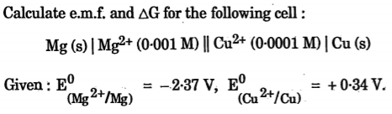

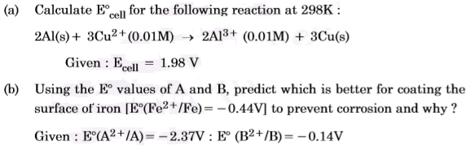

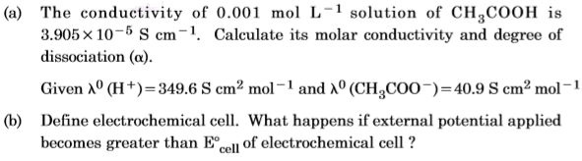

1. Calculate e.m.f of the following cell at 298 K :

2Cr(s) + 3Fe2+ (0.1M) → 2Cr3+ (0.01M) + 3 Fe(s)

Given: E° (Cr3+ | Cr) = – 0.74 V E° (Fe2+ | Fe) = – 0.44 V

1. 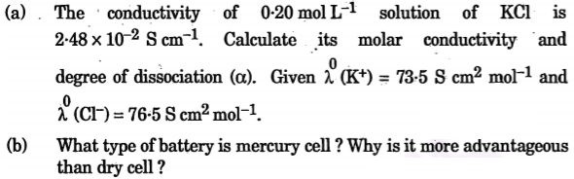
2. From the given cells: Lead storage cell, Mercury cell, Fuel cell and Dry cell answer the following: (i) Which cell is used in hearing aids?

(ii) Which cell was used in Apollo Space Programme? (iii) Which cell is used in automobiles and inverters? (iv) Which cell does not have long life?

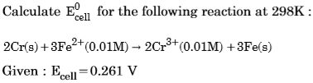

1. Calculate the degree of dissociation (α) of acetic acid if its molar conductivity (∧m) is 39.05 S cm2mol–1. Given λo(H+) = 349.6 S cm2 mol–1 and λo(CH3COO–) = 40.9 S cm2 mol–1
2. (a) Calculate the mass of Ag deposited at cathode when a current of 2 amperes was passed through a solution of AgNO3 for 15 minutes.

(Given: Molar mass of Ag = 108 g mol–1 1F = 96500 C mol–1)

(b) Define fuel cell.

1. In a galvanic cell, the following cell reaction occurs:

Zn (s) + 2 Ag+ (aq) → Zn2+ (aq) + 2 Ag (s) Eocell = + 1·56 V

(a) Is the direction of flow of electrons from zinc to silver or silver to zinc?

(b) How will concentration of Zn2+ ions and Ag+ ions be affected when the cell functions?

1. A current of 1.50 A was passed through an electrolytic cell containing AgNO3 solution with inert electrodes. The weight of silver deposited was 1.50 g. How long did the current flow?(Molar mass of Ag =108 g mol–1, 1F = 96500Cmol–1).
2. The conductivity of a 0.01 M solution of acetic acid at 298 K is 1.65 × 10–4 S cm–1. Calculate molar conductivity (λm) of the solution.
3. Consider the following reaction: Cu(s) + 2Ag+ (aq) → 2Ag(s) + Cu2+ (aq)

(i) Depict the galvanic cell in which the given reaction takes place.

(ii) Give the direction of flow of current.

(iii) Write the half-cell reactions taking place at cathode and anode.

1. E0cell for the given redox reaction is 2.71 V

Mg(s) + Cu2+(0.01 M) → Mg2+(0.001 M) + Cu(s)

Calculate Ecell for the reaction. Write the direction of flow of current when an external opposite potential applied is (i) less than 2.71 V and (ii) greater than 2.71 V.

1. (a) A steady current of 2 amperes was passed through two electrolytic cells X and Y connected in series containing electrolytes FeSO4 and ZnSO4 until 2.8 g of Fe deposited at the cathode of cell X. How long did the current flow? Calculate the mass of Zn deposited at the cathode of cell Y.(Molar mass: Fe = 56 g mol–1 Zn = 65.3 g mol–1, 1F = 96500 C mol–1)

(b) In the plot of molar conductivity (λm) vs square root of concentration (c1/2), following curves are obtained for two electrolytes A and B:

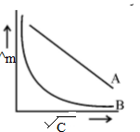

Answer the following: (i) Predict the nature of electrolytes A and B.

(ii) What happens on extrapolation of ^m to concentration approaching zero for electrolytes A and B?

1. (a) The conductivity of 0·001 mol L–1 acetic acid is 4·95 × 10–5 S cm–1. Calculate the dissociation constant if λom for acetic acid is 390·5 S cm2 mol–1.

(b) Write Nernst equation for the reaction at 250C:

2 Al (s) + 3 Cu2+ (aq) → 2 Al3+ (aq) + 3 Cu (s)

(c) What are secondary batteries? Give an example.

1. (a) Represent the cell in which the following reaction takes place:

2 Al (s) + 3 Ni2+ (0·1 M) →2 Al3+ (0·01 M) + 3 Ni (s).

Calculate its emf if E0cell = 1·41 V.

(b) How does molar conductivity vary with increase in concentration for strong electrolyte and weak electrolyte? How can you obtain limiting molar conductivity (λ0m) for weak electrolyte?

1. (a) Following reaction takes place in the cell :

Zn (s) + Ag2O (s) + H2O (*l*) →Zn2+ (aq) + 2Ag (s) + 2OH– (aq).

Calculate ∆rG0 of the reaction. [Given: E0Zn2+/Zn = – 0·76 V, E0Ag+/Ag = 0·80 V, 1 F = 96,500 C mol–1]

(b) How can you determine limiting molar conductivity, (λ0 m) for strong electrolyte and weak electrolyte?

1. Calculate ∆rG0 and log KC for the following reaction :

Cd+2(aq) + Zn(s) → Zn2+(aq) + Cd(s) ;Given: E0Cd2+/Cd = – 0·403 V, E0Zn2+/Zn = – 0·763 V

1. Chromium metal is electroplated using an acidic solution containing CrO3 according to the following equation: CrO3 (aq) + 6H+ + 6e- → Cr(s) + 3H2O

Calculate how many grams of chromium will be electroplated by 24,000 coulombs. How long will it take to electroplate 1·5 g chromium using 12·5 A current? [Atomic mass of Cr = 52 g mol-1, 1 F = 96500 C mol-1]

1. Following reactions may occur at cathode and anode during electrolysis of aqueous sodium chloride. What products will be held at anode and cathode?

Use given E0 values to justify your answer.

**Cathode:** Na+ (aq) + e– → Na(s); E0 = – 2·71 V,

H+ (aq) + e– → 1/2 H2 (g) E0 = 0·00 V

**Anode:** Cl– (aq) → 1/2 C*l*2 (g) + e–; E0 = + 1·36 V,

2H2O (aq) → O2 (g) + 4H+ + 4e– E0 = + 1·23 V

1. Calculate the emf of the following cell at 250C :

Al (s) |Al3+ (0·001 M) || (0·1) Ni2+ |Ni (s)

Given: E0Ni2+/Ni = – 0·25 V, E0 Al3+/Al = – 1·66 V; [log 2 = 0·3010, log 3 = 0·4771]

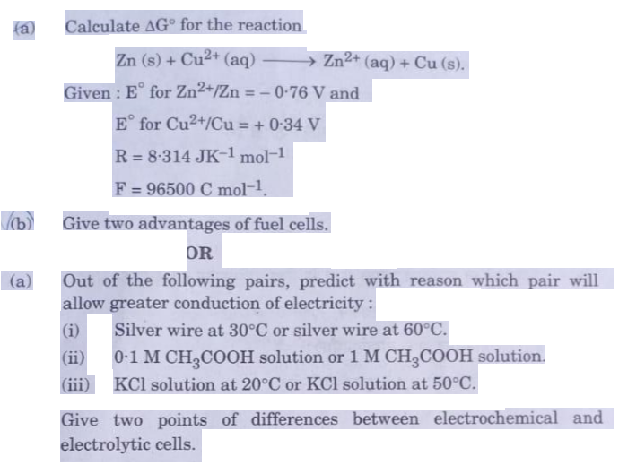

1. Calculate the maximum work and log KC for the reaction at 298 K,

Ni (s) + 2 Ag**+** (aq) Ni**2+** (aq) +2 Ag (s)

Given; E0Ni2+/Ni = – 0·25, E0Ag+1/Ag = +0.80 V, 1F = 96500 C mol**-1**.

**………………..**